PROJECT REPORT TEMPLATE

1. INTRODUCTION

Appstrail is a company that specializes in providing digital transformation solutions using Salesforce technology for retail sales force management. Salesforce offers a range of solutions for consumer goods and retail companies, including tools for managing field sales teams and their activities. When used correctly and strategically, Salesforce can support field sales teams in consumer goods and retail companies.

* 1. Overview :

Retailing encompasses the business activities involved in selling and services to consumers for their personal, family or household etc., When is retail management? Retail management refers to the process of helping customers find products in your store. It includes everything from increasing your customer pool to how products are presented, and how you fulfill a customer’s needs.

* 1. Purpose :
* Retail management application is used to store customers data and to provide support to customers in dealing cases.
* To generate business on top of the customers, that will help you sell smarter and faster.
* Retail management software is technology that helps business owners drive more sales with application that include point of sale features, inventory management, retail customer relationship management and more. These solutions often include hardware for payment terminals and can support mobile devices.

1. Problem Definition and Design thinking :
   1. : EMPATHY MAP :

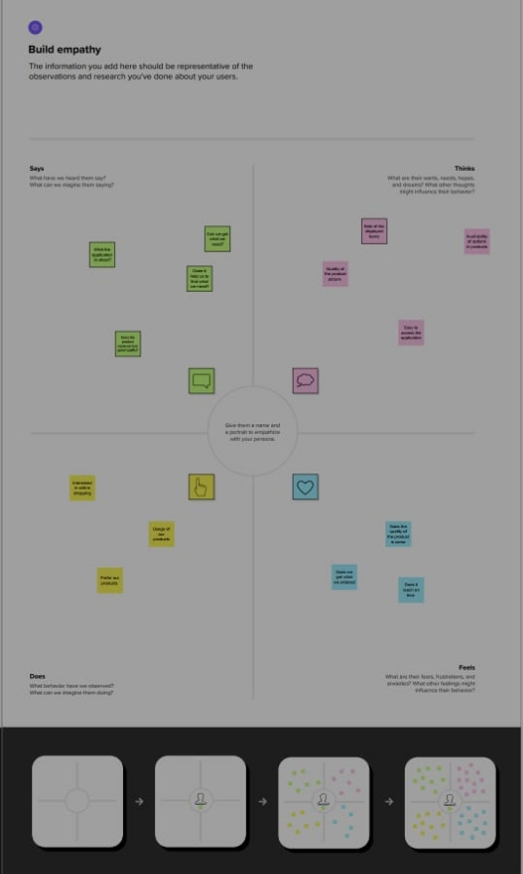

* 1. : IDEATION AND BRAINSTORMING :

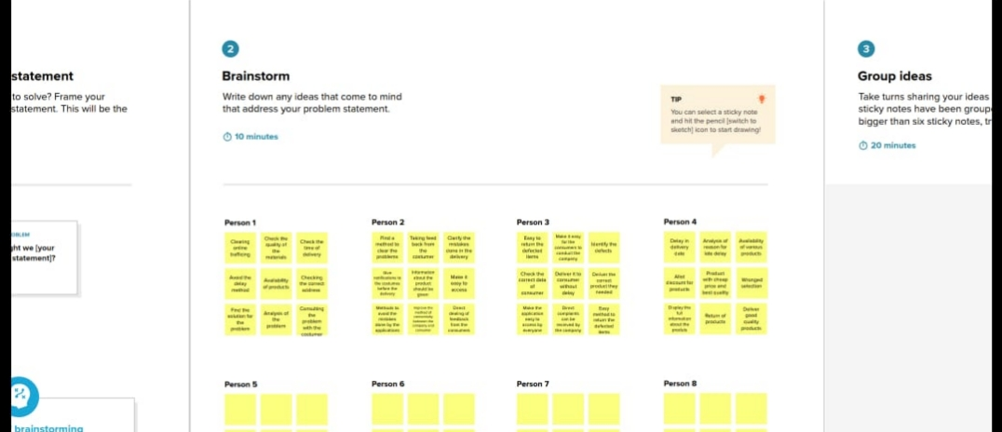

RESULT

3.1 Data Model

|  |  |
| --- | --- |
| Object name | Field in the Object |
| Obj 1 :  Accounts | |  |  | | --- | --- | | Field label | Data type | | Accounts | Text | | Dispatched | Time | | Service Appointment | Master detail | | Tracking | Checkbox | |
| Obj 2 :  Contact | |  |  | | --- | --- | | Account website | Formula | |

3.2 Activity & Screenshot :

* To create the object go to salesforce.com.
* After login this homepage will display

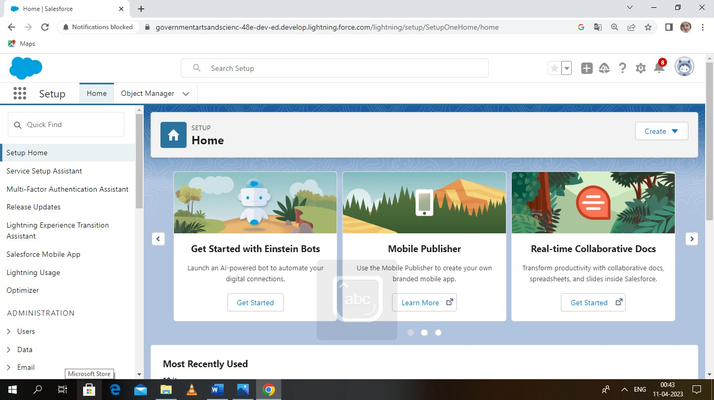

* Objects are Database tables that permit you to store data in an organization .

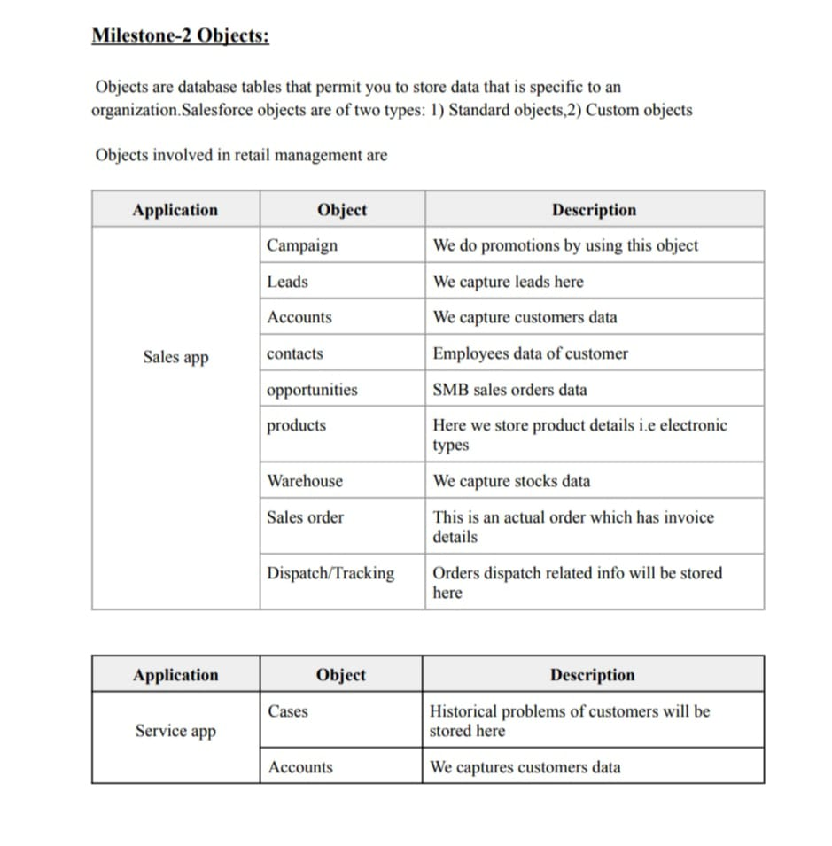

* To create field : select field and relationship option.

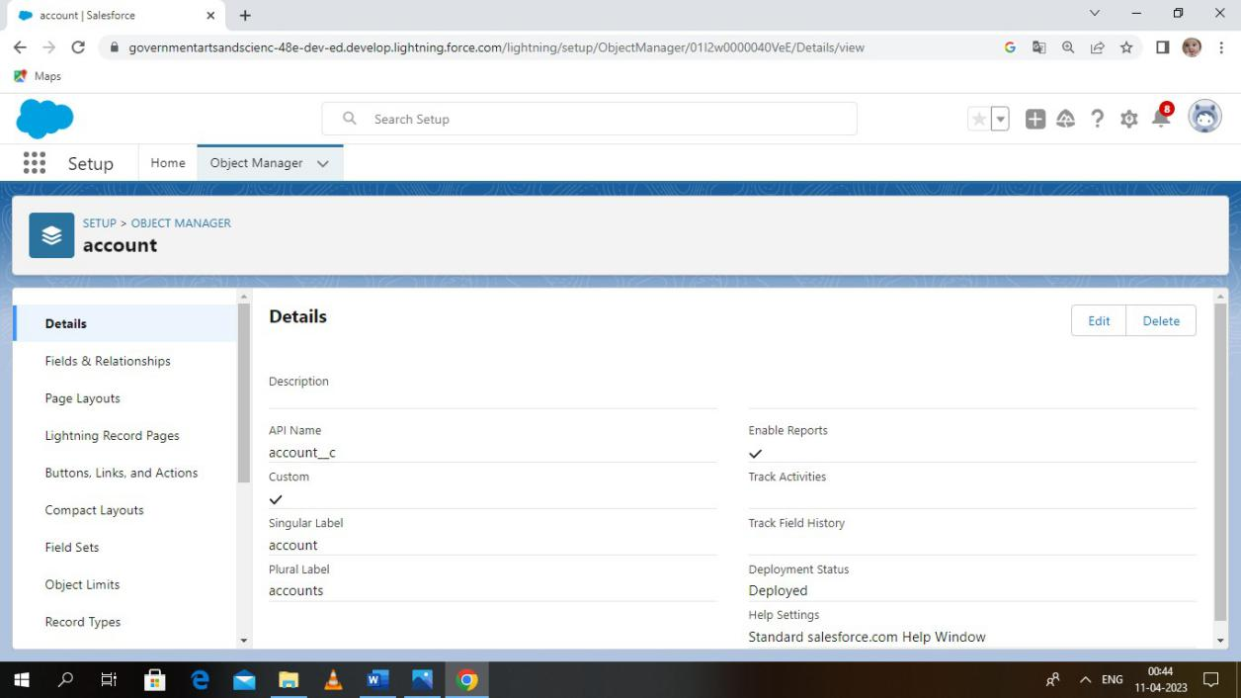

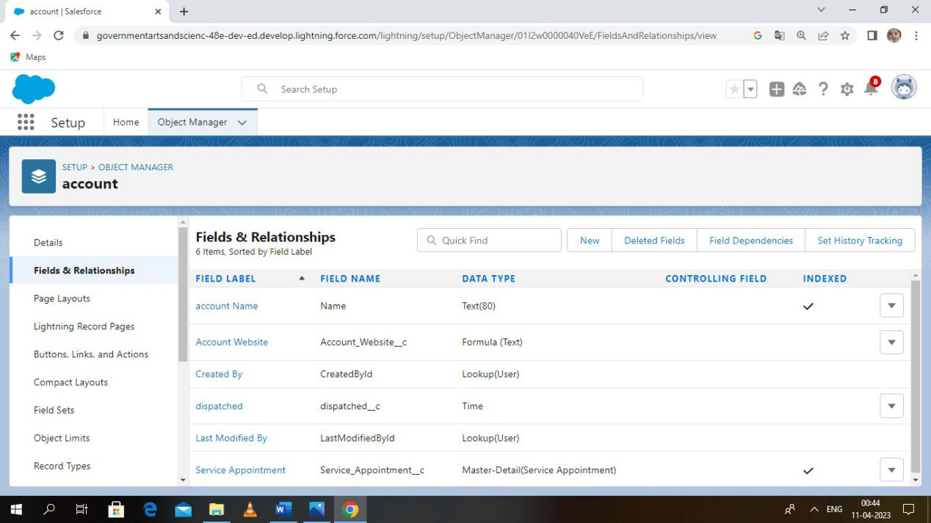

* Create relationship between objects from homepage using object manager.

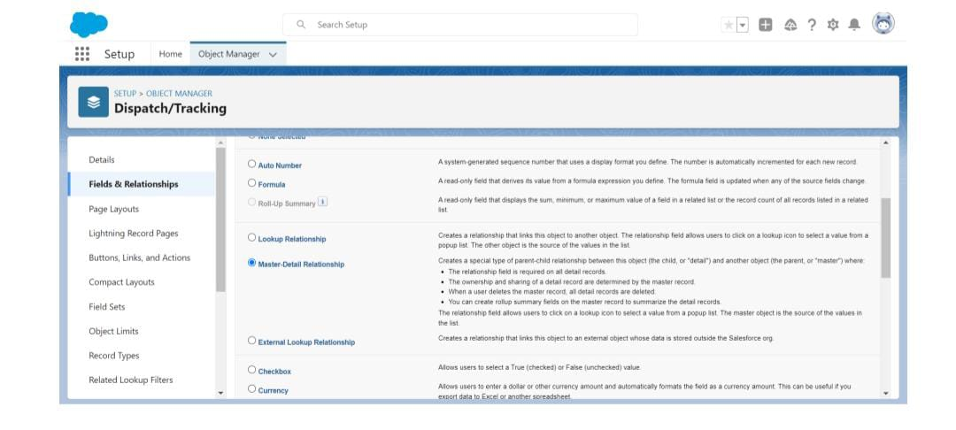

* Create application file using app manager.
* To create the page layout which control the layout object.

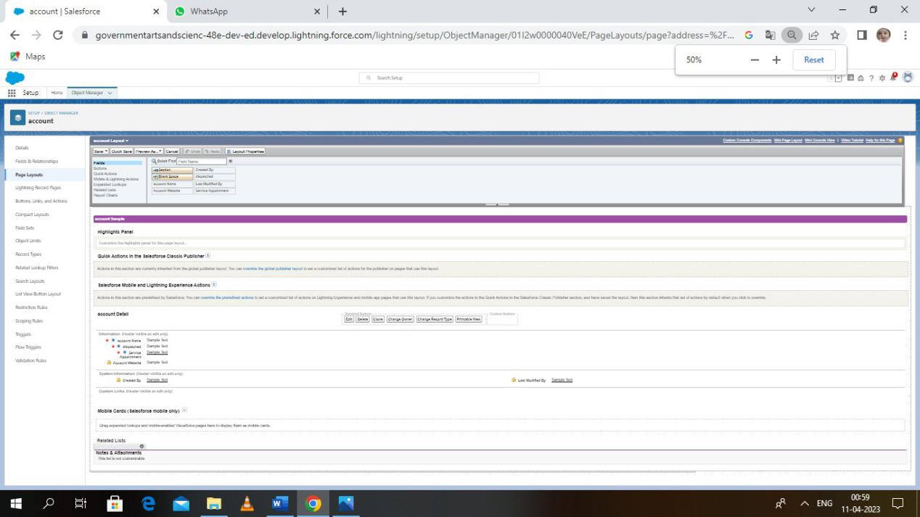

* To create user ID.

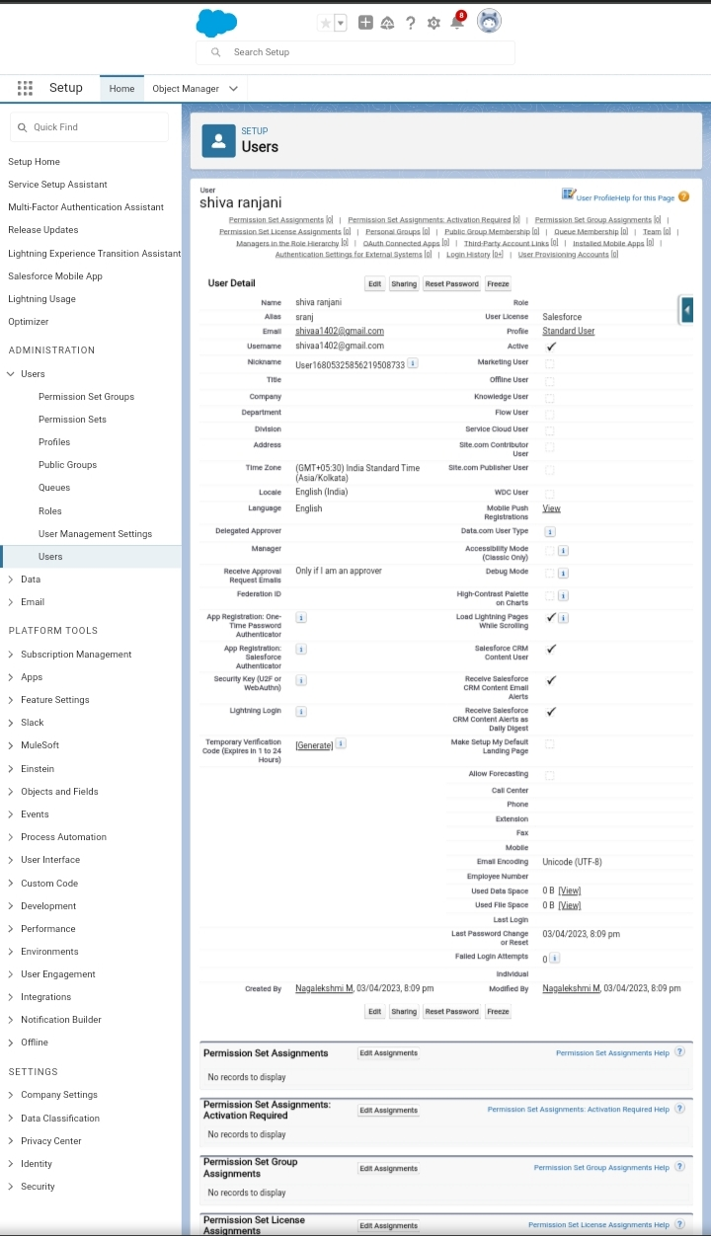

* To create validation rule navigate to object manager.

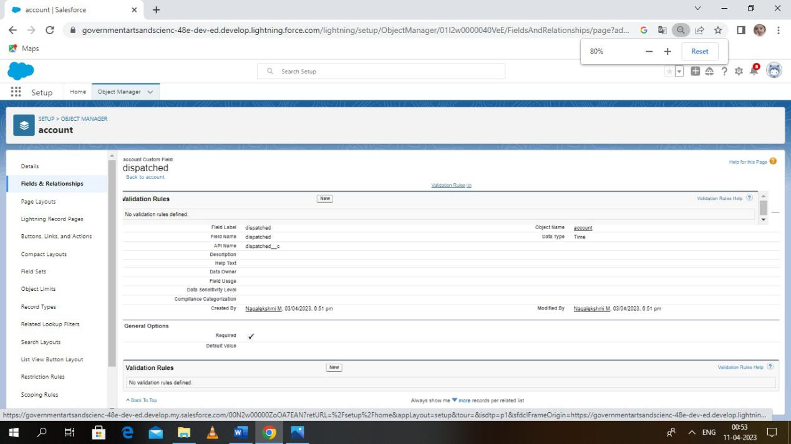

* To create the report click on the app launcher.

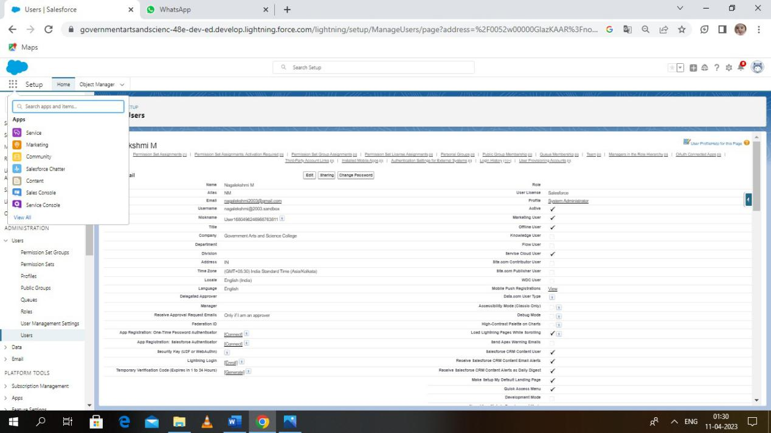

* Click on new report and create it.

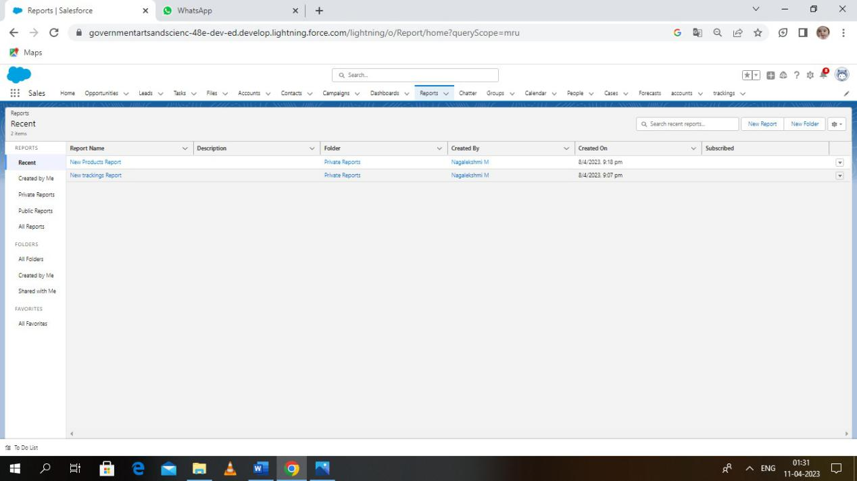

* Dashboard is created.
* The dashboard has product with stock availability.

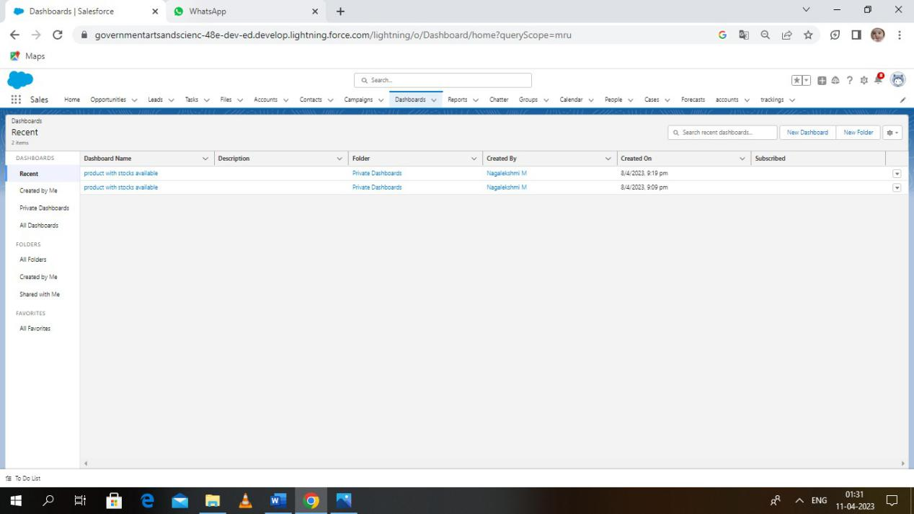

* The report is created and saved.

NEW PRODUCTS REPORT

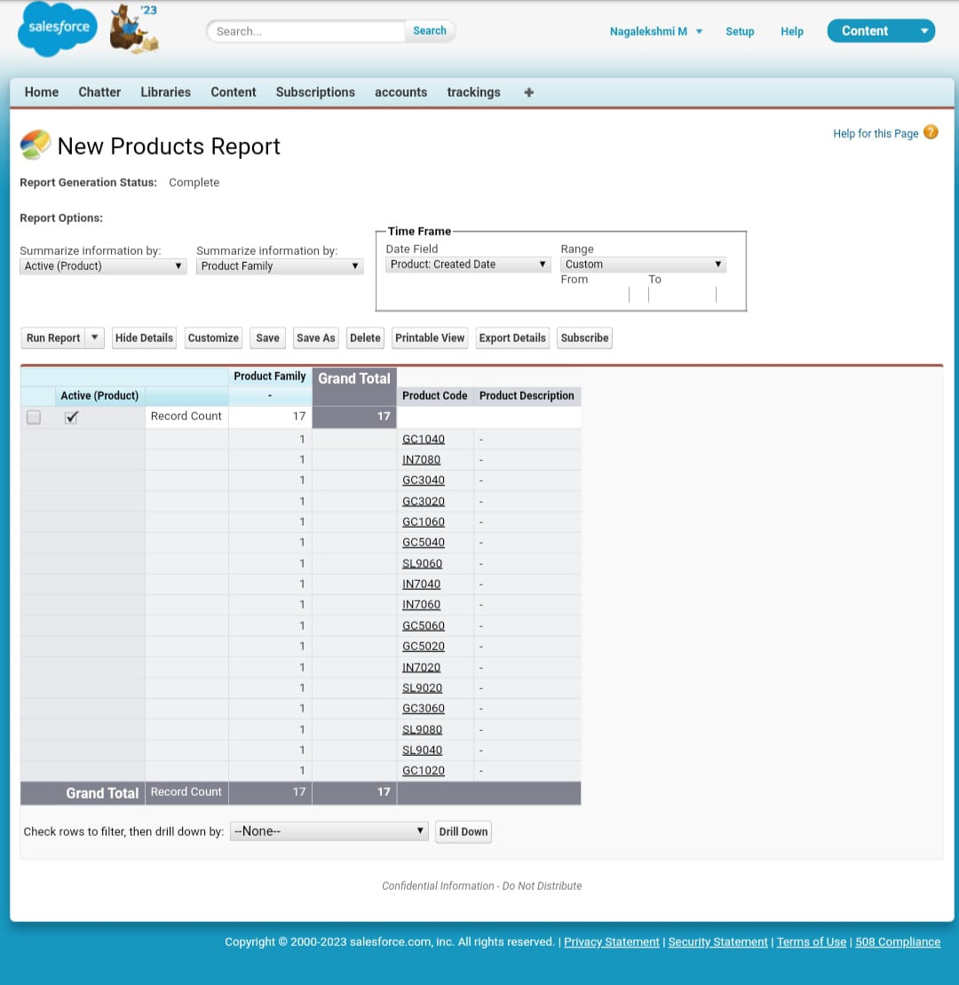

PRODUCT WITH STOCKS AVAILABLE

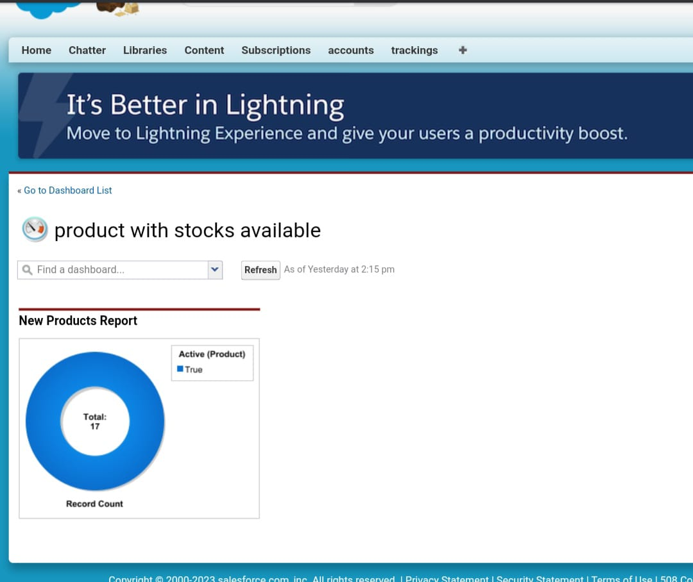

* This is the graphical representation of the report.

Trailhead Profile Public URL :

Team Lead : <https://trailblazer.me/id/iranjaniav>

Team Member 1 : <https://trailblazer.me/id/ii24m>

Team Member 2 : <https://trailblazer.me/id/ii19s>

Team Member 3 : <https://trailblazer.me/id/ikumarvr>

ADVANTAGES & DISADVANTAGES

ADVANTAGES

* Automated Sales Process
* Improved Customer Relationships
* Enhanced Lead Management
* Reduced Time and Effort Required
* Enhanced Productivity
* Greater Flexibility and Control

DISADVANTAGES

* Reviewing job applications and interviewing candidates
* Training new team members
* Setting up displays and promotions
* Answering customer questions and resolving complaints
* Maintaining sales records
* Overseeing markdowns, sales and pricing

APPLICATIONS

* Inventory Management Software
* Accounting Software
* CRM Software
* Merchandise Sales Data and Analytics Software
* E-commerce (Omnichannel) Software
* Business Intelligence Software
* Warehouse Management and Logistics Software

CONCLUSION :

* In this course we have explored the meaning of the terms retailing ,marketing and marketing communications.
* We have also considered the importance of the marketing mix and identified the different communication tools that a retailer might use to interact and communicate with their target customers.

FUTURE SCOPE :

These small retail shops can use the internet to extend their space. If retailers are able to help customers order products online while they’re in the store and have those products shipped to the customer’s house ,they’ll win a lot of business. This is great customer service, but of course it requires retail management software. By improving the software it creates a great impact in Retail Management.